
ABC Private Limited
Travel & Expense Management App
Pre-travel approval · Booking · Expense statement with bills · Approvals · Payment · Analytics · PWA
PROJECT SUMMARY DOCUMENT
Version 1.0 · 27 September 2026

Contents
1. Executive Summary
2. Requirement Coverage
3. Solution Architecture
4. User Roles and Access
5. Travel Workflow
6. Matrix of Authority and Travel Policy
7. Corporate Features Included
8. Analytics Dashboard and Exception Flags
9. Progressive Web App (Install Support)
10. Database Design
11. Installation and Getting Started
12. Testing and Quality
13. Contents of the ZIP File
14. Notes, Limitations and Roadmap

1. Executive Summary
This project delivers a complete, ready-to-run Travel & Expense Management application for ABC Private Limited. It digitises the full corporate travel cycle – from the sales person's pre-travel approval request, through Business Head and Managing Director approval, booking of flights and hotels by the Travel Assistant as per the Matrix of Authority, to the post-travel expense statement with attached bills, its approval by the Business Head and HR Head, and finally accounting and payment by the Accountant.
The application has a backend server with a SQLite database that stores all users, sign-in/sign-up records, requests, approvals, bookings, expense lines, bills and payments. Access is controlled by a login page (email id + password) with sign-up; the first user to sign up becomes the Admin, and afterwards only email ids added by the Admin can sign up.
Admins get a visual analytics dashboard with employee-wise, destination-wise, airline-wise, department-wise and monthly spend, a lead-time-versus-airfare analysis supporting the advance-planning policy, and an automatic exception report (late booking, hotel/flight above grade, over-budget claims, missing or duplicate bills, and more).
The app is a full Progressive Web App (PWA): Chrome and Edge show "Install App" on desktop, Android shows "Add to Home screen", iPhone users get guided instructions, and an Install App button sits in the top menu bar. It works on desktop, tablet and mobile.

Key facts
Item | Detail
Technology | Node.js 22+ backend (built-in HTTP + SQLite), vanilla HTML/CSS/JavaScript PWA front-end – zero third-party packages
Database | SQLite file data/abc_travel.db (11 tables), auto-created on first run; bills stored in uploads/
Users & roles | Admin + 10 standard roles in a drop-down (MD, Business Head, Sales Manager, Sales Executive, HR Head, Accountant, Travel Assistant, Finance Manager, Operations Manager, Employee) + custom roles
Workflow | 9-step workflow with send-back / reject at every approval stage, notifications and full audit trail
How to run | Double-click Start_ABC_Travel_App.bat (Windows) – opens http://localhost:8080
Quality | 43 automated API checks + full browser end-to-end run across all 7 roles – all passed; Chrome reports zero PWA installability errors

2. Requirement Coverage
Every requirement in the brief and how it is delivered:
# | Requirement | Delivered as
1 | Travel expense app for "ABC Private Limited" (multinational) | Branded PWA; Domestic & International trips; multi-currency expense lines with exchange rates to INR
2 | Pre-travel approval workflow, clearly identified | Visual 9-step workflow stepper on every request; role-based work queues; workflow diagram on dashboard and policy page
3 | Backend database for users and task details | SQLite database with users, sessions, auth_logs, travel_requests, request_history, expense_items, attachments, notifications, settings, authority_matrix, feature boards
4 | Login page with email id and password; sign-up option | Login / Sign Up tabs; salted scrypt password hashing; 7-day sessions; lock-out after 5 failed attempts
5 | First user becomes Admin | First successful sign-up is automatically given Admin rights (logged as such)
6 | Admin adds employees and their email ids | Employees screen: add / edit / deactivate, bulk CSV import, reset password, grant admin
7 | Employee signs up with the id entered by Admin; others refused | Sign-up checks the employee master; any other email id is refused and the attempt is logged
8 | Employee can see and edit pending approvals | My Trips & Claims with filters; edit while Draft / Sent back / pending first approval; cancel before booking; approvers edit budgets and claim line amounts in their queue
9 | Only Admin sees the entire employee dashboard | Analytics, All Requests, Employees, Settings and Logs are Admin-only (server-enforced)
10 | Save all sign-in and sign-up details in database | auth_logs table: SIGNUP_SUCCESS / REJECTED, LOGIN_SUCCESS / FAILED / BLOCKED, LOGOUT, password and employee changes with IP & device; Admin log screen
11 | Request: cities, days, approximate amount, flight, hotel, food & misc, purpose | All fields plus local conveyance, client, cost center, preferences, advance; auto days and total; auto-fill from policy
12 | Business Head → Managing Director approval | Routed to employee's reporting BH, then MD; approve (revise budget) / send back / reject
13 | Support person books flight & hotel as per Matrix of Authority (5/4/3 Star) | Travel Assistant booking desk shows entitlement; bookings above grade need justification and are flagged; e-ticket / voucher upload
14 | Expense statement with bills attached after travel | Expense lines with category, vendor, bill no., currency; PDF/JPG/PNG bills (camera on phone); bills mandatory above limit
15 | Claim → Business Head → HR Head (final) | Line-wise approved amounts with notes; send back loop to employee
16 | Accountant: accounting and payment processing | Voucher no., GL code, cost center, payment mode, UTR, date; advance adjustment; net payable / recoverable
17 | Plan travel well in advance for cheaper tickets | Configurable minimum advance days (default 14); live indicator; justification for late requests; late-booking exception; lead-time vs fare chart
18 | Visual dashboard: employee, destination, airline wise; analytics; flag exceptions | Admin analytics with 8 charts, KPI tiles, date filters, exception report, CSV export
19 | Roles drop-down for Admin | Role drop-down in employee form; list editable in Settings
20 | Typical corporate features + option to add more | Notifications, audit trail, advances, multi-currency, print, backup, policy page, settings & feature switches, editable Matrix of Authority, feature suggestion board, enhancement prompts
21 | Full PWA install support + Install button in menu bar | Manifest, icons (incl. maskable), service worker, shortcuts, screenshots, beforeinstallprompt handling, iOS guidance, Install App button
22 | Single ZIP with summary, prompts, examples, executables, supporting docs | ABC_Travel_Expense_Project.zip – see Section 13

3. Solution Architecture
The solution is intentionally simple to install and maintain – one folder, one program, one database file.
Layer | Implementation
Client (PWA) | public/index.html, app.js (single-page app, hash routing), charts.js (SVG charts), styles.css (responsive, light/dark), manifest.webmanifest, sw.js (service worker), icons
Server | server.js – Node.js HTTP(S) server, REST API (~45 endpoints), role checks, workflow engine, exception engine, file upload handling, CSV export, backup
Database | SQLite via Node.js built-in node:sqlite – WAL mode, foreign keys, indexes; no database server to install
File storage | uploads/ folder – bills, e-tickets, hotel vouchers, payment proofs (PDF/JPG/PNG/WEBP/HEIC, ≤5 MB, SHA-256 duplicate detection)
Launchers | launch.js (version check, flags, opens browser, --demo mode); Start_ABC_Travel_App.bat, Start_Demo_Mode.bat, Start_ABC_Travel_App.command, start_mac_linux.sh
Security | scrypt password hashes, random 256-bit session tokens, login throttling, server-side role enforcement on every endpoint, no self-approval, upload type/size whitelist, full audit trail

4. User Roles and Access
Role | What the role does in the app
Admin | First user. Adds employees and email ids, assigns roles/Business Heads, resets passwords, sets policy & Matrix of Authority, views analytics, all requests, sign-in/sign-up log, exports and backups. Can act on any stage (recorded as Admin override).
Sales Executive / Sales Manager / any employee | Raises pre-travel requests, edits pending requests, cancels, receives bookings, submits expense statement with bills, tracks reimbursement.
Business Head | First approver of travel requests (can revise budget) and of expense statements (can edit approved amount per line). Own requests skip this stage.
Managing Director | Final pre-travel approval. Own requests go directly to booking.
Travel Assistant | Booking Desk: books flights and hotels as per the Matrix of Authority and attaches tickets / vouchers.
HR Head | Final approval of the expense statement.
Accountant | Accounts Desk: disburses travel advances, posts vouchers, adjusts advances and records payment.
Finance Manager, Operations Manager, custom roles | Behave as employees with their own entitlement row in the Matrix of Authority.

Rules: nobody can approve their own request; a request waiting for a specific Business Head is visible only to that Business Head; every action and comment is stored in the request history.

5. Travel Workflow
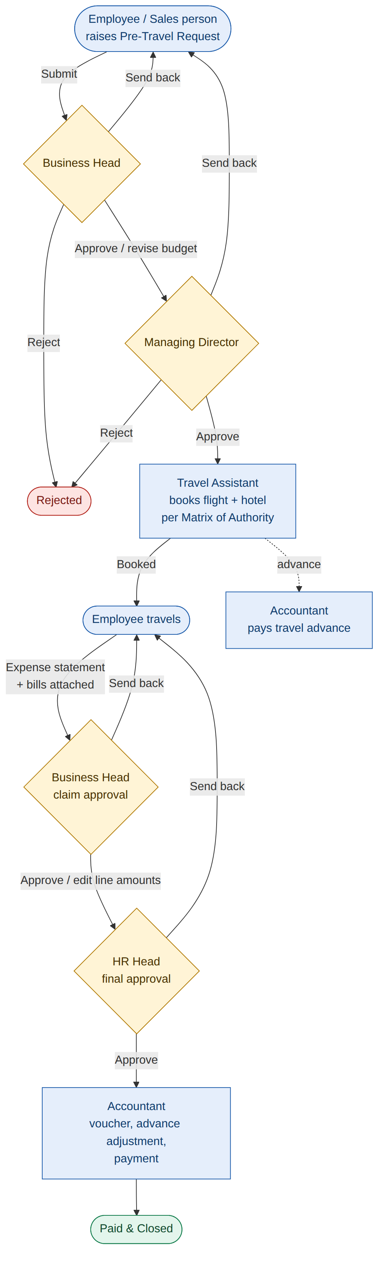
Figure 1 – Pre-travel approval, booking, expense statement and payment workflow
Stage | Owner | Actions available
Draft / Sent back | Employee | Edit, submit, cancel
Pending Business Head | Reporting Business Head | Approve (revise budget), send back, reject; employee can still edit until first action
Pending Managing Director | Managing Director | Approve, send back, reject
Pending Travel Booking | Travel Assistant | Book flight + hotel (justify if above entitlement), attach tickets, send back; Accountant may pay advance
Booked | Employee | Travel; add expense lines and bills; submit expense statement
Claim Pending Business Head | Business Head | Edit approved amount per line, approve, send back, reject
Claim Pending HR Head | HR Head | Final approval, send back, reject
Pending Accounting & Payment | Accountant | Voucher, GL code, cost center, payment mode/UTR/date; advance adjustment
Paid & Closed | – | Read-only; printable statement

6. Matrix of Authority and Travel Policy
Default travel entitlements (editable by Admin in Policy & Settings). They drive the request form hints, the Travel Assistant's booking limits, the auto-fill estimates and the exception engine.
Role | Flight | Hotel | Hotel max / night | Food DA / day | Local / day
Managing Director | Business | 5 Star | ₹15,000 | ₹3,000 | ₹2,000
Business Head | Premium Economy | 5 Star | ₹10,000 | ₹2,500 | ₹1,500
HR Head | Economy | 4 Star | ₹7,000 | ₹2,000 | ₹1,200
Finance Manager | Economy | 4 Star | ₹7,000 | ₹2,000 | ₹1,200
Operations Manager | Economy | 4 Star | ₹6,500 | ₹1,800 | ₹1,000
Sales Manager | Economy | 4 Star | ₹6,000 | ₹1,500 | ₹1,000
Admin | Economy | 4 Star | ₹6,000 | ₹1,500 | ₹1,000
Sales Executive | Economy | 3 Star | ₹4,000 | ₹1,000 | ₹800
Accountant | Economy | 3 Star | ₹4,000 | ₹1,000 | ₹800
Travel Assistant | Economy | 3 Star | ₹4,000 | ₹1,000 | ₹800
Employee | Economy | 3 Star | ₹3,500 | ₹900 | ₹600

Policy rules (configurable)
- Advance planning: request at least 14 days before departure; late requests need a justification and are flagged.
- Bills: mandatory for each expense above ₹500.
- Over-budget tolerance: claims more than 10% above the approved budget are flagged.
- Claim deadline: expense statement within 15 days of return; overdue claims are flagged.
- Maximum trip length: 30 days guideline.
- Feature switches: international travel & multi-currency, travel advance, feature board, mandatory late-booking justification.

7. Corporate Features Included
- Role-based work queues: Pending Approvals (BH / MD / HR), Booking Desk (Travel Assistant), Accounts Desk (Accountant) with count badges.
- Notifications: in-app bell for every submission, approval, send-back, booking, advance and payment.
- Audit trail: every create, edit, approval, budget revision, booking, advance and payment with user, role, time and comment.
- Travel advance: requested in the form, paid by the Accountant, automatically adjusted at settlement (net payable or recoverable).
- Bill attachments: per expense line and per request; camera capture on phones; duplicate file detection.
- Multi-currency: foreign-currency expenses converted to INR at editable default rates.
- Printing: print-friendly travel & expense statement.
- Exports & backup: full register as CSV (Excel), one-click database backup.
- Employee master: CSV bulk import, deactivate leavers, reset passwords, reporting Business Head mapping.
- Travel policy page showing rules, workflow and Matrix of Authority to all employees.
- Extensibility: editable roles, departments, expense categories, airlines, currencies; feature suggestion board with voting and status; ready-made prompts for 14 future enhancements.

8. Analytics Dashboard and Exception Flags
Available to Admin only, filterable by travel date (custom, financial year, last 90 days, all time).
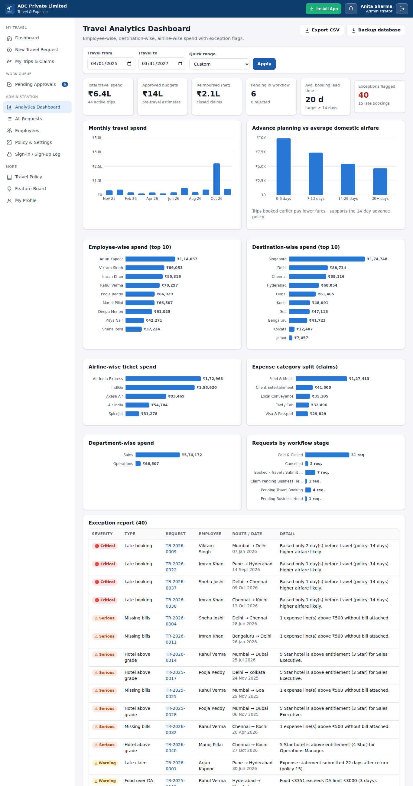
Figure 2 – Analytics dashboard with demo data
- KPI tiles: total spend, approved budgets, net reimbursed, pending in workflow, average booking lead time, exceptions.
- Charts: monthly spend; advance planning vs average domestic airfare; employee-wise; destination-wise; airline-wise; expense category; department-wise; workflow stage.
- Exception report and employee-wise summary table; each row opens the request.

Exception flags
Flag | Severity | Raised when
Late booking | Warning / Critical | Request raised fewer than the minimum advance days before travel (critical under 3 days)
Hotel above grade | Serious | Hotel category higher than the role's entitlement
Hotel rate over limit | Warning | Nightly rate above the entitlement limit
Flight class above grade | Serious | Flight class higher than entitlement
Over budget | Serious | Claim exceeds approved budget by more than the tolerance
Missing bills | Serious | Expense line above the bill limit without a bill
Duplicate bill | Critical | Same category, amount, date and bill no. repeated; same file uploaded before
Food over DA | Warning | Food total above daily allowance × days
Date outside trip | Warning | Expense dated outside the travel period
Long trip | Warning | Trip longer than the maximum days guideline
Late claim / Claim overdue | Warning | Expense statement submitted, or still pending, after the deadline

9. Progressive Web App (Install Support)
- Web manifest: name, short name, standalone display, theme colour, start URL and scope, 192/512 px icons plus maskable icon, three app shortcuts, wide and narrow screenshots for the richer install dialog.
- Service worker: caches the app shell for fast start and offline opening; API calls always go to the server so data is live.
- Install App button in the top menu bar (and on the login page) triggers the browser's install prompt; on iPhone/iPad or unsupported browsers it shows step-by-step instructions.
- Verified: Chrome DevTools reports no installability or manifest errors.
Important: browsers allow installation only from https:// or http://localhost. Use HTTPS for phones and other PCs (see Deployment_and_HTTPS_Guide.md).
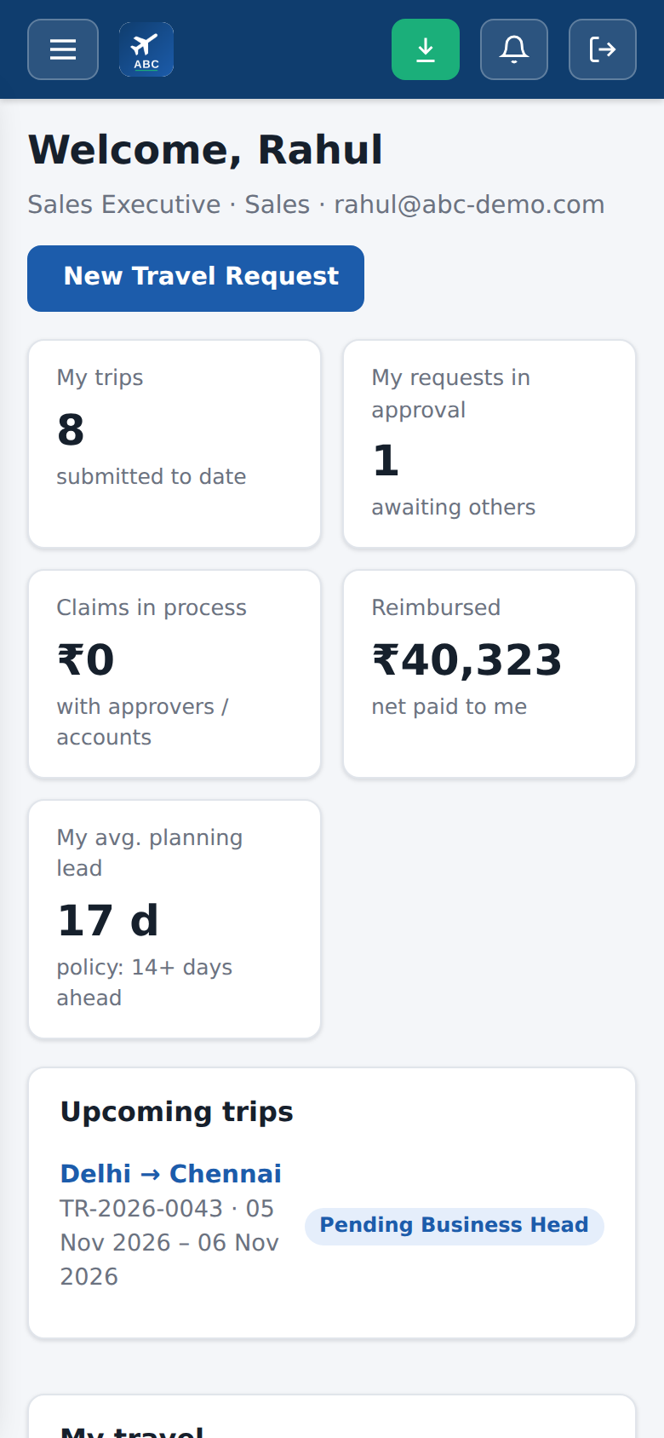
Figure 3 – Mobile view with Install button (green) in the menu bar

10. Database Design
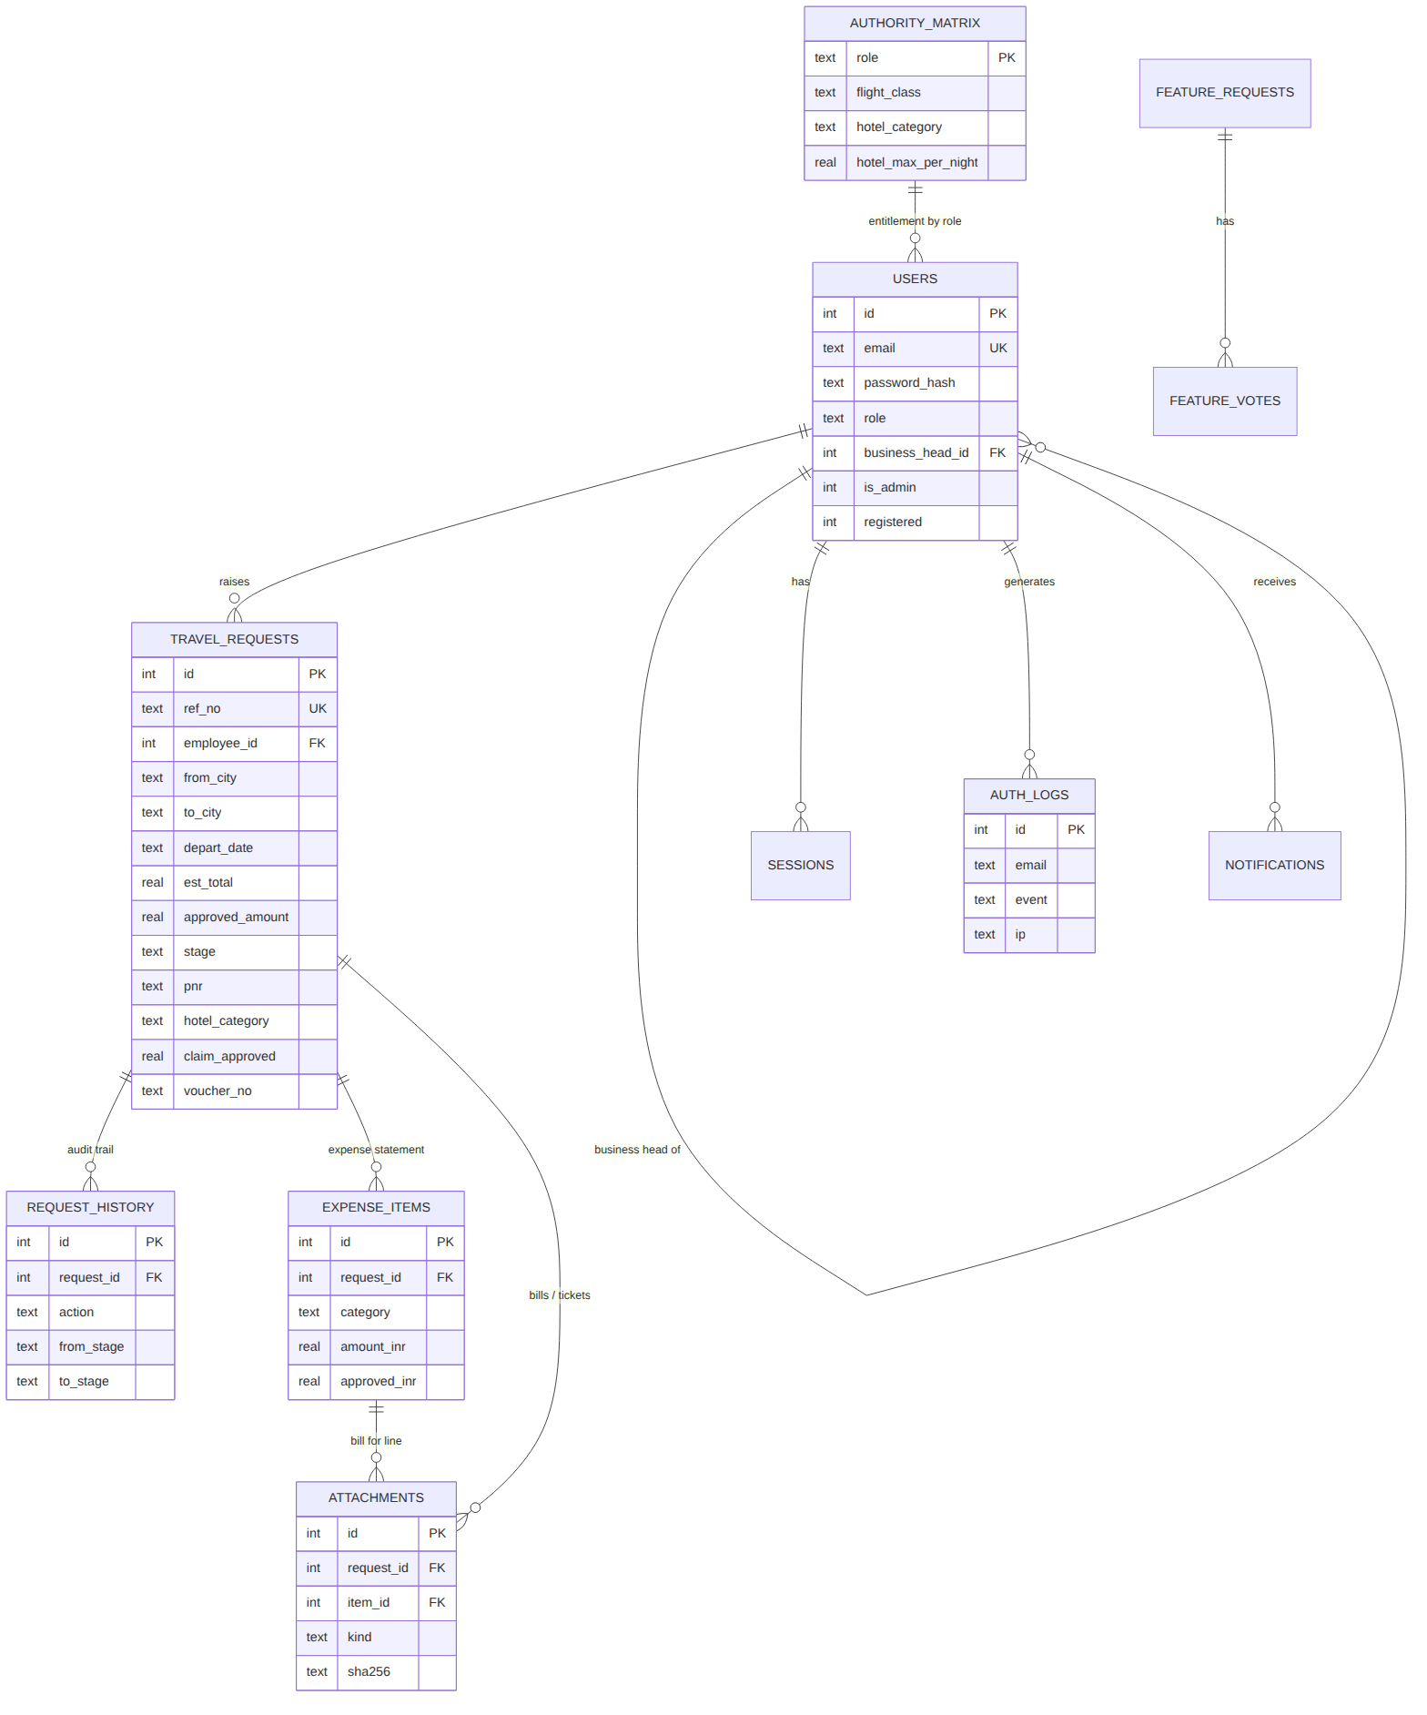
Figure 4 – Entity relationship diagram (key columns)
Table | Purpose
users | Employee master and login credentials (hash + salt), role, department, reporting Business Head, admin flag, sign-up status
sessions | Active login sessions with expiry, IP and device
auth_logs | All sign-up, sign-in, failed, blocked, logout, password and employee/settings change events
travel_requests | Request, estimates, approval, booking, claim totals and payment details, current stage
request_history | Audit trail of every workflow action with comments
expense_items | Expense statement lines, currency, INR amount, approved amount and approver note
attachments | Bills, tickets, vouchers, payment proofs (metadata + SHA-256)
notifications | In-app notifications per user
settings / authority_matrix | Policy values, master lists, feature switches / role entitlements
feature_requests / feature_votes | Feature suggestion board
Full DDL: 05_Supporting_Documents/Database_Schema.sql.

11. Installation and Getting Started

Requirements
Windows 10/11 (or macOS / Linux) with Node.js 22 LTS or newer. The Windows launcher installs Node.js automatically via winget if it is missing. No other software or database server is needed.

Start the app
- Unzip ABC_Travel_Expense_Project.zip.
- Open 04_Executable_Application\ABC_Travel_Expense_App and double-click Start_ABC_Travel_App.bat.
- The browser opens at http://localhost:8080. Keep the console window open (it is the server).
- Click Sign Up – the first person becomes Administrator. Log in.
- Go to Employees and add Business Head, Managing Director, Travel Assistant, HR Head, Accountant and sales staff (or import Sample_Employee_Import.csv).
- Each employee opens the same address, signs up with the email id the Admin entered, and logs in.
- Click Install App in the menu bar to install it as a desktop / mobile app.

Try it with demo data
Double-click Start_Demo_Mode.bat – it builds a demo database (15 employees, 46 trips at every stage with exceptions) and opens http://localhost:8081. Log in as admin@abc-demo.com / Demo@1234 (all demo users use Demo@1234).

Day-to-day use by role
User | Steps
Employee | New Travel Request → fill route, dates, purpose, estimates (or Auto-fill) → Submit. After booking: open the trip → Add expense + attach bill for each item → Submit expense statement.
Business Head | Pending Approvals → open → revise budget if needed → Approve / Send back / Reject. For claims: adjust line amounts with notes → Approve.
Managing Director | Pending Approvals → open → Approve / Send back / Reject.
Travel Assistant | Booking Desk → open → enter airline, flight, PNR, fare, hotel, category, nights, rate → attach e-ticket → Confirm booking.
HR Head | Pending Approvals → review claim and bills → Approve.
Accountant | Accounts Desk → record advances; for approved claims enter voucher, GL, payment mode, UTR, date → Post voucher & mark paid.
Admin | Analytics Dashboard, All Requests (Export CSV), Employees, Policy & Settings, Sign-in / Sign-up Log, Backup database.

12. Testing and Quality
Test | Scope | Result
Automated API workflow test (npm test) | Sign-up rules, admin, employees, request, edit rules, BH/MD approvals, advance, Matrix of Authority, bills, claim approvals with send-back, payment and advance adjustment, special routing, analytics access, logs, notifications | 43 / 43 passed
Browser end-to-end test | Complete trip through the real UI with 7 different logins on a fresh database | Passed – Paid & Closed
PWA audit | Chrome installability & manifest checks, service worker | No errors
Responsive check | Phone 390 px, 540 px, laptop 1280 / 1366 px | Passed
Data tools | CSV import (8 employees), CSV export, demo data generator | Passed
Detailed log: 05_Supporting_Documents/Test_Report.txt.

13. Contents of the ZIP File
Folder / file | Description
00_READ_ME_FIRST.txt | Quick start and index
01_Summary_Document/ABC_Travel_Expense_Project_Summary.docx (.pdf) | This document
02_Prompt_Files/01_Original_User_Prompt.txt | The original requirement as given
02_Prompt_Files/02_Detailed_Build_Specification_Prompt.md | Reusable detailed specification prompt
02_Prompt_Files/03_Future_Enhancement_Prompts.md | 14 ready prompts for adding more features
03_Example_Files/Sample_Bills/ | Sample hotel invoice, taxi receipt, restaurant bill, airline e-ticket (PDF, marked as samples)
03_Example_Files/Sample_Employee_Import.csv | Template for bulk employee import
03_Example_Files/Example_Demo_Database_abc_travel_demo.db | Demo SQLite database with 46 trips
03_Example_Files/Example_Travel_Register_Export.csv | Example CSV export from the demo
03_Example_Files/Example_Walkthrough_Test_Scenario.md | Step-by-step demo / training script
03_Example_Files/Example_Screenshots/ | 26 screenshots of every screen and role, desktop and mobile
04_Executable_Application/ABC_Travel_Expense_App/ | Complete application: launchers (.bat / .command / .sh), server.js, launch.js, public/ (PWA), tools/, tests/, README.md
05_Supporting_Documents/ | Workflow diagram, ER diagram, Database_Schema.sql, API_Reference.md, Matrix_of_Authority_Default.csv, PWA_Installation_Guide.md, Deployment_and_HTTPS_Guide.md, Test_Report.txt

14. Notes, Limitations and Roadmap
- Runtime: the "executable" is a one-click launcher that runs on Node.js 22+ (installed automatically on Windows). A self-contained .exe was not produced because it requires platform binaries that were not available in the build environment.
- Notifications are in-app; email / WhatsApp / push alerts are listed as enhancements.
- Mobile installation requires the app to be served over HTTPS (browser rule).
- Fares are entered by the Travel Assistant; live airline / travel-agency integration is a roadmap item.
- Exchange rates are maintained by Admin in Settings.
Suggested next features: email alerts, delegation of authority, SLA escalation, OCR of bills, corporate card reconciliation, Tally Prime voucher export, department budgets, single sign-on, web push, multi-entity support (see 03_Future_Enhancement_Prompts.md).

